|  |  |
| --- | --- |
| **Test Case:** *Pesquisa teste*  **Expected Result:** *teste*  **Status:** | **Date :** *24/08/2020*  **Hour:** *12:04* |

**1. OBJECTIVE**

This document aims to provide proof of the tests run for application validation.

2. EVIDENCE OF TEST STEPS

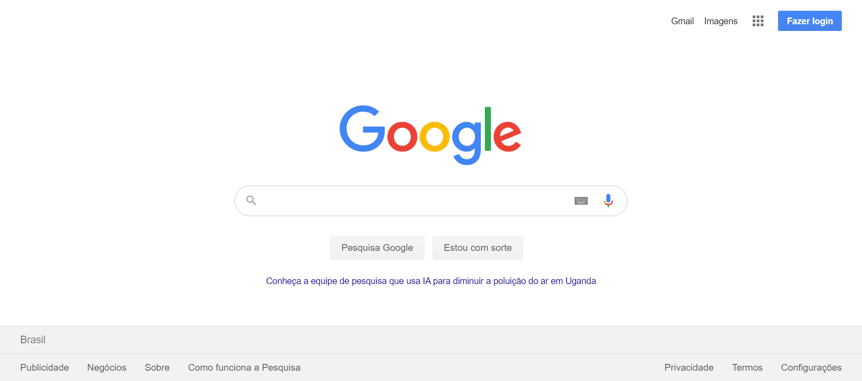

|  |  |
| --- | --- |
| Action: Navigate | Action time: 00:00:05 |
| Resultado expect: The page was successfully loaded | Resultado obtained: The page was successfully loaded |

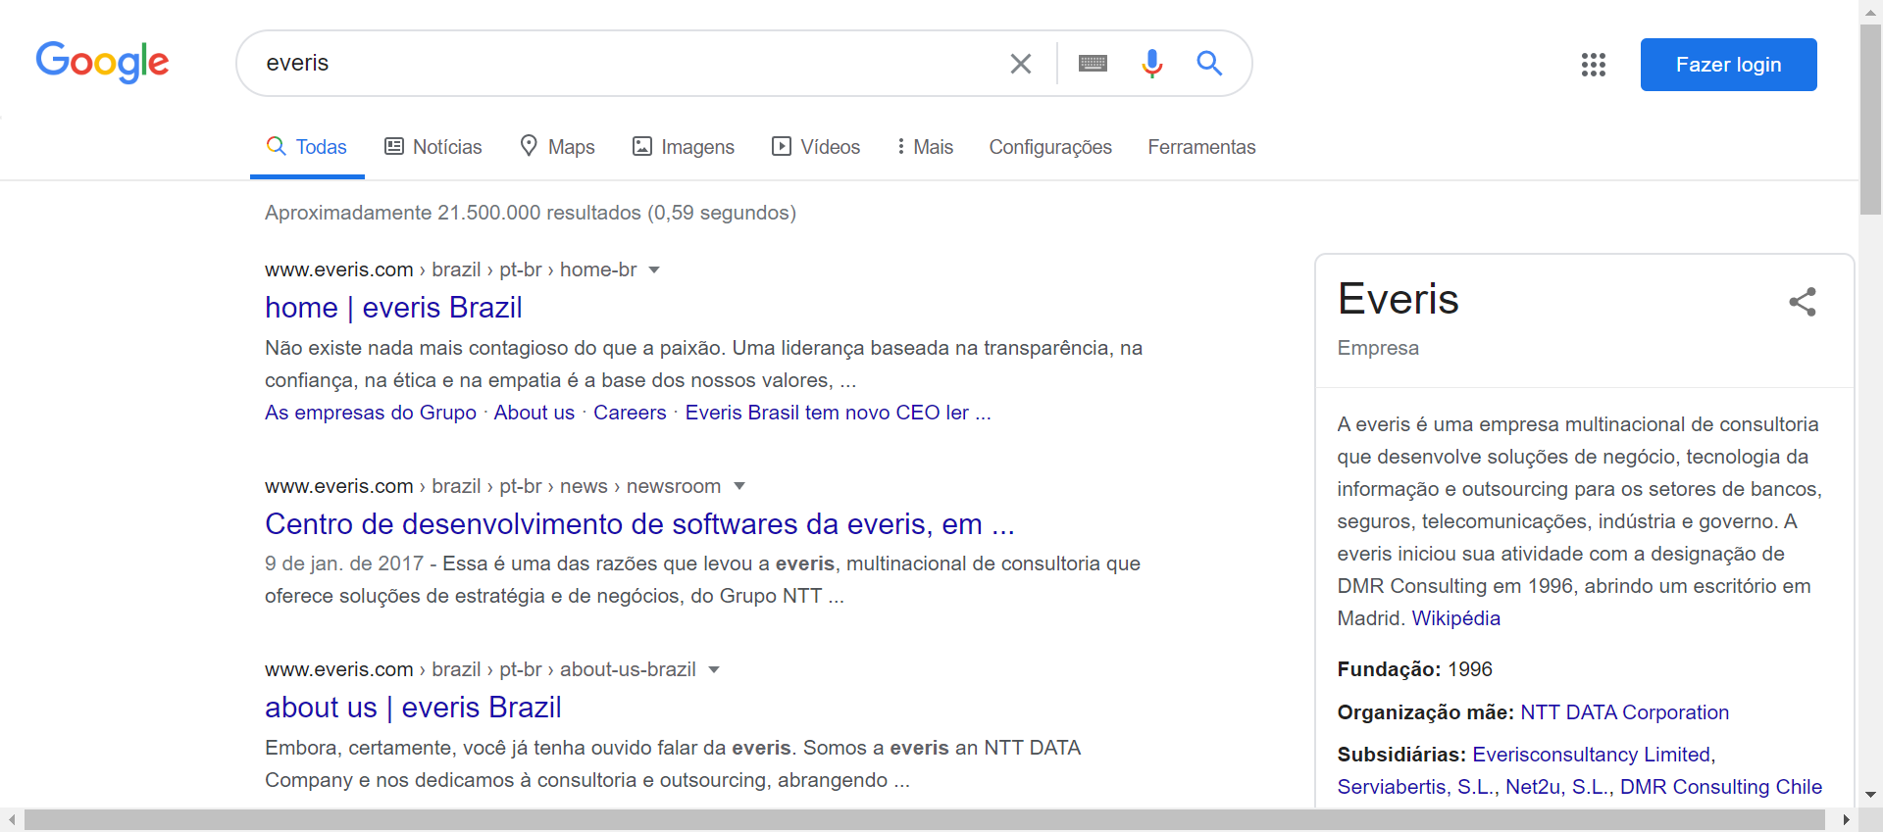

|  |  |
| --- | --- |
| Action: SendKeys | Action time: 00:00:04 |
| Resultado expect: The field was successfully filled | Resultado obtained: The field was successfully filled |



|  |  |
| --- | --- |
| Action: getText | Action time: 00:00:00 |
| Resultado expect: The text is successfully retrieved | Resultado obtained: The text is successfully retrieved |